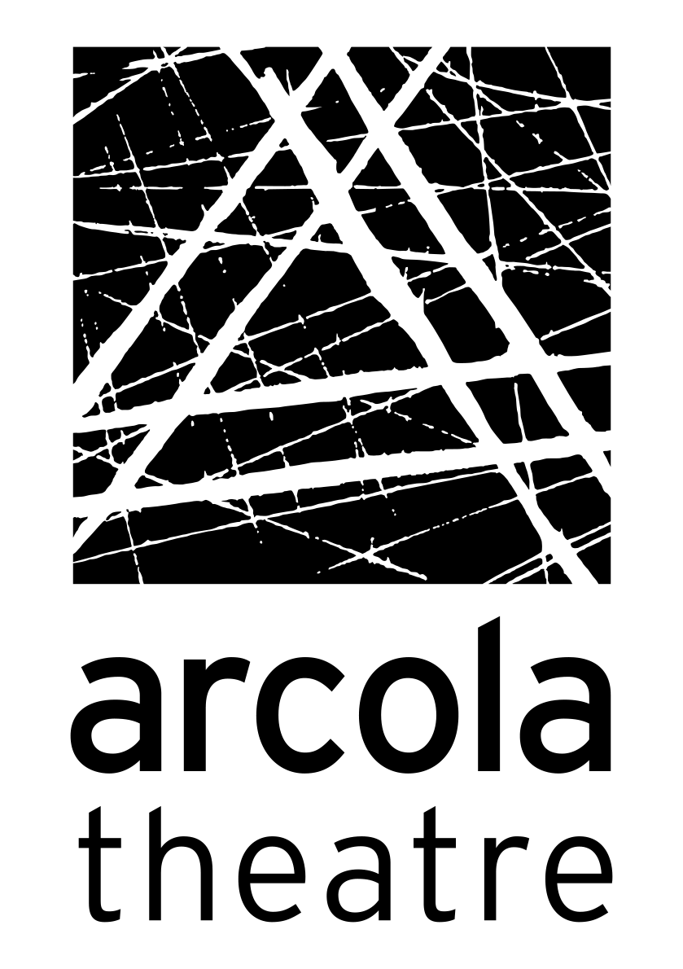 Arcola Theatre Participation - We are hiring!

Assistant Facilitators
Assistant Producer
New training roles for young and emerging creatives (18-30) who identify as LGBTQIA+ to work with Arcola Queer Collective this summer. Due to funding, positions are for those living in Hackney, Newham, Tower Hamlets or Waltham Forest.
Are you interested in community theatre? Are you good at working with people of all ages to create art? We are looking for three young or emerging creatives to join our team this summer to help us deliver our Summer 2024 Queer Collective project.
The participants will take part in workshops from writing to drag, voguing, devised theatre, movement and poetry.
No experience required, this is a training programme. You will be working with two experienced theatre facilitators and a theatre producer. If you have experience then this is an opportunity to hone your skills and develop your professional practice.
Please send a CV and covering letter (1 page) to participation@arcolatheatre.com
Deadline: Friday 26th April 12 midday.
Interviews in person at Arcola Theatre: Producer roles will be Wednesday 1st May between 2pm-5pm and Facilitator roles will be Friday 3rd May between 11am-3pm
Role commence dates: w/c 6th May - w/c 5th August, 1 day a week
Fee Trainee Assistant Facilitator: £400 for 15 sessions
Fee Trainee Assistant Producer: £1,092 for 1 day a week for 12 days.
Facilitators need to be available on Thursday evening between 6pm-9.30pm (please note exact times may change)
Producer role is an office based position. Thursdays 9.30am-5.30pm

